**Lab Web Scrapping Space X Falcon 9 First Stage Landing Prediction**

Web scraping Falcon 9 and Falcon Heavy Launches Records from Wikipedia

Estimated time needed: **40** minutes

In this lab, you will be performing web scraping to collect Falcon 9 historical launch records from a Wikipedia page titled List of Falcon 9 and Falcon Heavy launches

<https://en.wikipedia.org/wiki/List_of_Falcon_9_and_Falcon_Heavy_launches>

Falcon 9 first stage will land successfully



Several examples of an unsuccessful landing are shown here:



More specifically, the launch records are stored in a HTML table shown below:

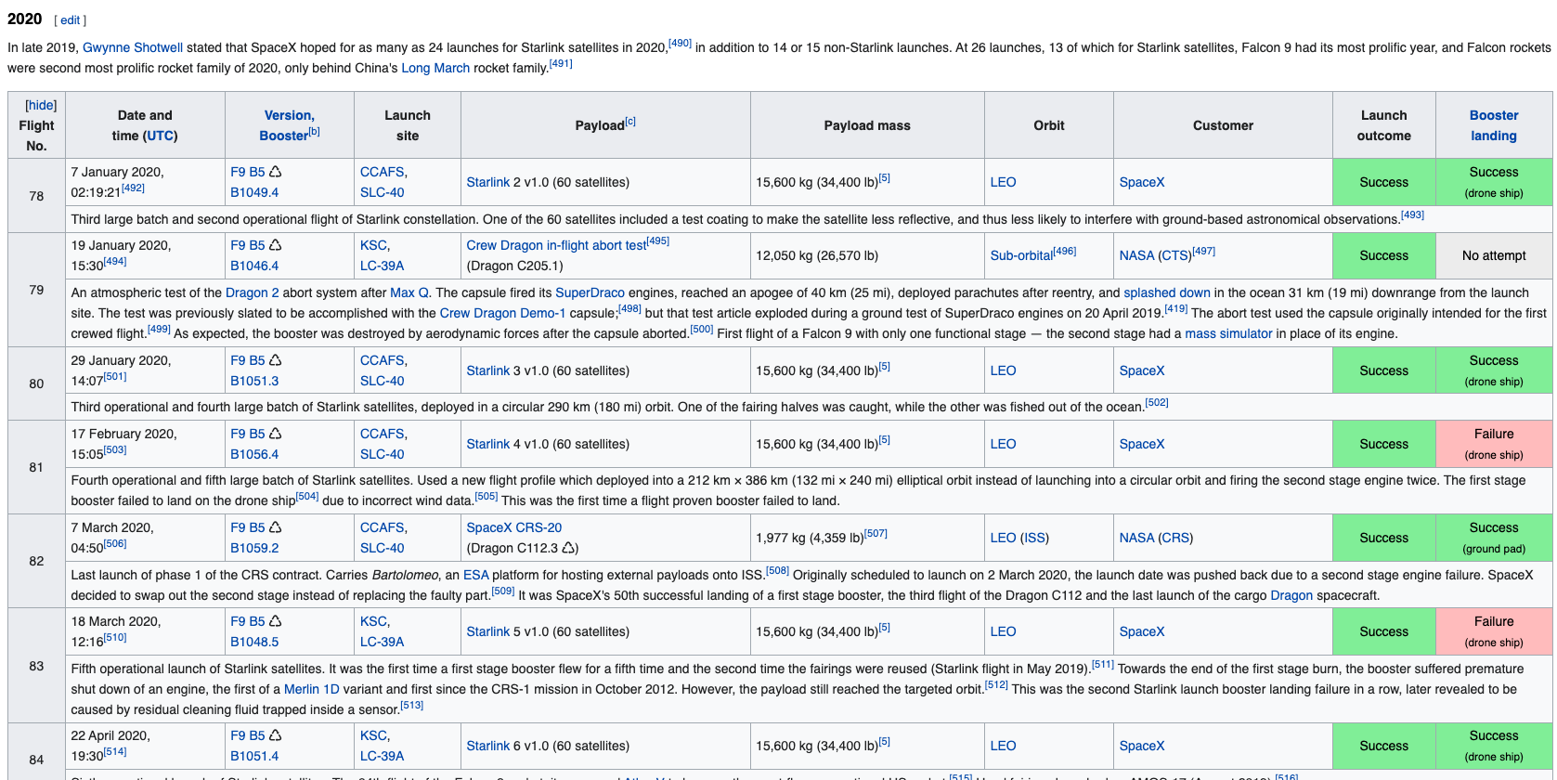

Objectives

Web scrap Falcon 9 launch records with BeautifulSoup:

* Extract a Falcon 9 launch records HTML table from Wikipedia
* Parse the table and convert it into a Pandas data frame

First let's import required packages for this lab

!pip3 install beautifulsoup4

!pip3 install requests

Then

import sys

import requests

from bs4 import BeautifulSoup

import re

import unicodedata

import pandas as pd

and we will provide some helper functions for you to process web scraped HTML table

def date_time(table_cells):

"""

This function returns the data and time from the HTML table cell

Input: the element of a table data cell extracts extra row

"""

return [data_time.strip() for data_time in list(table_cells.strings)][0:2]

def booster_version(table_cells):

"""

This function returns the booster version from the HTML table cell

Input: the element of a table data cell extracts extra row

"""

out=''.join([booster_version for i,booster_version in enumerate( table_cells.strings) if i%2==0][0:-1])

return out

def landing_status(table_cells):

"""

This function returns the landing status from the HTML table cell

Input: the element of a table data cell extracts extra row

"""

out=[i for i in table_cells.strings][0]

return out

def get_mass(table_cells):

mass=unicodedata.normalize("NFKD", table_cells.text).strip()

if mass:

mass.find("kg")

new_mass=mass[0:mass.find("kg")+2]

else:

new_mass=0

return new_mass

def extract_column_from_header(row):

"""

This function returns the landing status from the HTML table cell

Input: the element of a table data cell extracts extra row

"""

if (row.br):

row.br.extract()

if row.a:

row.a.extract()

if row.sup:

row.sup.extract()

colunm_name = ' '.join(row.contents)

# Filter the digit and empty names

if not(colunm_name.strip().isdigit()):

colunm_name = colunm_name.strip()

return colunm_name

To keep the lab tasks consistent, you will be asked to scrape the data from a snapshot of the List of Falcon 9 and Falcon Heavy launches Wikipage updated on 9th June 2021

static_url = "https://en.wikipedia.org/w/index.php?title=List_of_Falcon_9_and_Falcon_Heavy_launches&oldid=1027686922"

headers = {

"User-Agent": "Mozilla/5.0 (Windows NT 10.0; Win64; x64) "

"AppleWebKit/537.36 (KHTML, like Gecko) "

"Chrome/91.0.4472.124 Safari/537.36"

}

Next, request the HTML page from the above URL and get a response object

TASK 1: Request the Falcon9 Launch Wiki page from its URL

First, let's perform an HTTP GET method to request the Falcon9 Launch HTML page, as an HTTP response.

# Extract the HTML content

html = response.text

# Use BeautifulSoup() to create a BeautifulSoup object from a response text content

soup = BeautifulSoup(html, "html.parser")

However a warning was given – since it detected webscrapping:

/home/jupyterlab/conda/envs/python/lib/python3.7/site-packages/bs4/__init__.py:439: MarkupResemblesLocatorWarning: The input looks more like a filename than markup. You may want to open this file and pass the filehandle into Beautiful Soup.

MarkupResemblesLocatorWarning

So Had to use code to mimic a real person:

# Add headers to mimic a browser

headers = {

'User-Agent': 'Mozilla/5.0 (Windows NT 10.0; Win64; x64) AppleWebKit/537.36 (KHTML, like Gecko) Chrome/115.0.0.0 Safari/537.36'

}

# Make the GET request with headers

response = requests.get(

'https://en.wikipedia.org/w/index.php?title=List_of_Falcon_9_and_Falcon_Heavy_launches&oldid=1027686922',

headers=headers

)

# Check status

print(response.status_code)

# If successful, parse the HTML

if response.status_code == 200:

html = response.text

soup = BeautifulSoup(html, "html.parser")

Print the page title to verify if the BeautifulSoup object was created properly

# Use soup.title attribute

print(soup.title.string)

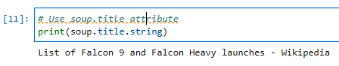

TASK 2: Extract all column/variable names from the HTML table header

Next, we want to collect all relevant column names from the HTML table header

Let's try to find all tables on the wiki page first. If you need to refresh your memory about BeautifulSoup, please check the external reference link towards the end of this lab

# Use the find_all function in the BeautifulSoup object, with element type `table`

# Assign the result to a list called `html_tables`

html_tables = soup.find_all('table')

print(len(html_tables))

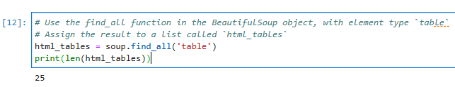

Starting from the third table is our target table contains the actual launch records.

# Let's print the third table and check its content

first_launch_table = html_tables[2]

print(first_launch_table)

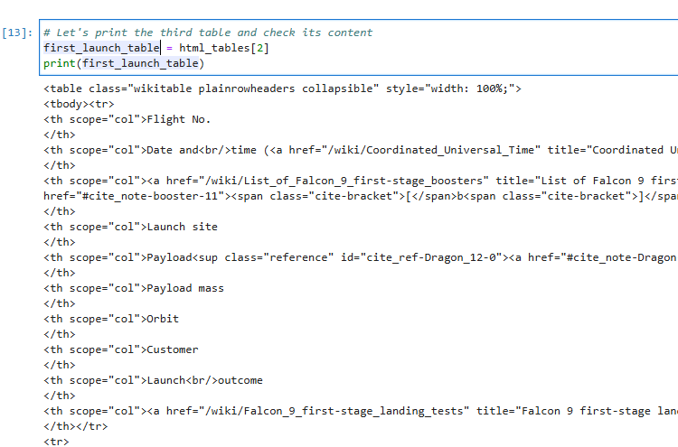

You should able to see the columns names embedded in the table header elements <th> as follows:

<tr>

<th scope="col">Flight No.

</th>

<th scope="col">Date and<br/>time (<a href="/wiki/Coordinated_Universal_Time" title="Coordinated Universal Time">UTC</a>)

</th>

<th scope="col"><a href="/wiki/List_of_Falcon_9_first-stage_boosters" title="List of Falcon 9 first-stage boosters">Version,<br/>Booster</a> <sup class="reference" id="cite_ref-booster_11-0"><a href="#cite_note-booster-11">[b]</a></sup>

</th>

<th scope="col">Launch site

</th>

<th scope="col">Payload<sup class="reference" id="cite_ref-Dragon_12-0"><a href="#cite_note-Dragon-12">[c]</a></sup>

</th>

<th scope="col">Payload mass

</th>

<th scope="col">Orbit

</th>

<th scope="col">Customer

</th>

<th scope="col">Launch<br/>outcome

</th>

<th scope="col"><a href="/wiki/Falcon_9_first-stage_landing_tests" title="Falcon 9 first-stage landing tests">Booster<br/>landing</a>

</th></tr>

Next, we just need to iterate through the <th> elements and apply the provided extract_column_from_header() to extract column name one by one

column_names = []

# Apply find_all() function with `th` element on first_launch_table

launch_table = soup.find_all('table')[2]

# Find the header row

header_row = launch_table.find('tr')

# Iterate each th element and apply the provided extract_column_from_header() to get a column names

header_cells = header_row.find_all('th')

# Append the Non-empty column name (`if name is not None and len(name) > 0`) into a list called column_names

for th in header_cells:

name = extract_column_from_header(th)

if name is not None and len(name) > 0:

column_names.append(name)

Check the extracted column names

print(column_names)



TASK 3: Create a data frame by parsing the launch HTML tables

We will create an empty dictionary with keys from the extracted column names in the previous task. Later, this dictionary will be converted into a Pandas dataframe

launch_dict= dict.fromkeys(column_names)

# Remove an irrelvant column

del launch_dict['Date and time ( )']

# Let's initial the launch_dict with each value to be an empty list

launch_dict['Flight No.'] = []

launch_dict['Launch site'] = []

launch_dict['Payload'] = []

launch_dict['Payload mass'] = []

launch_dict['Orbit'] = []

launch_dict['Customer'] = []

launch_dict['Launch outcome'] = []

# Added some new columns

launch_dict['Version Booster']=[]

launch_dict['Booster landing']=[]

launch_dict['Date']=[]

launch_dict['Time']=[]

Next, we just need to fill up the launch_dict with launch records extracted from table rows.

Usually, HTML tables in Wiki pages are likely to contain unexpected annotations and other types of noises, such as reference links B0004.1[8], missing values N/A [e], inconsistent formatting, etc.

To simplify the parsing process, we have provided an incomplete code snippet below to help you to fill up the launch_dict. Please complete the following code snippet with TODOs or you can choose to write your own logic to parse all launch tables: extracted_row = 0

#Extract each table

for table_number,table in enumerate(soup.find_all('table',"wikitable plainrowheaders collapsible")):

# get table row

for rows in table.find_all("tr"):

#check to see if first table heading is as number corresponding to launch a number

if rows.th:

if rows.th.string:

flight_number=rows.th.string.strip()

flag=flight_number.isdigit()

else:

flag=False

#get table element

row=rows.find_all('td')

#if it is number save cells in a dictonary

if flag:

extracted_row += 1

# Flight Number value

# TODO: Append the flight_number into launch_dict with key `Flight No.`

launch_dict['Flight No.'].append(flight_number)

#print(flight_number)

datatimelist=date_time(row[0])

# Date value

# TODO: Append the date into launch_dict with key `Date`

date = datatimelist[0].strip(',')

launch_dict['Date'].append(date)

#print(date)

# Time value

# TODO: Append the time into launch_dict with key `Time`

time = datatimelist[1]

launch_dict['Time'].append(time)

#print(time)

# Booster version

# TODO: Append the bv into launch_dict with key `Version Booster`

bv=booster_version(row[1])

if not(bv):

bv=row[1].a.string

launch_dict['Version Booster'].append(bv)

print(bv)

# Launch Site

# TODO: Append the bv into launch_dict with key `Launch Site`

launch_site = row[2].a.string

launch_dict['Launch site'].append(launch_site)

#print(launch_site)

# Payload

# TODO: Append the payload into launch_dict with key `Payload`

payload = row[3].a.string

launch_dict['Payload'].append(payload)

#print(payload)

# Payload Mass

# TODO: Append the payload_mass into launch_dict with key `Payload mass`

payload_mass = get_mass(row[4])

launch_dict['Payload mass'].append(payload_mass)

#print(payload)

# Orbit

# TODO: Append the orbit into launch_dict with key `Orbit`

orbit = row[5].a.string

launch_dict['Orbit'].append(orbit)

#print(orbit)

# Customer

# TODO: Append the customer into launch_dict with key `Customer`

customer = row[6].a.string if row[6].a else row[6].get_text(strip=True)

launch_dict['Customer'].append(customer)

#print(customer)

# Launch outcome

# TODO: Append the launch_outcome into launch_dict with key `Launch outcome`

launch_outcome = list(row[7].strings)[0]

launch_dict['Launch outcome'].append(launch_outcome)

#print(launch_outcome)

# Booster landing

# TODO: Append the launch_outcome into launch_dict with key `Booster landing`

booster_landing = landing_status(row[8])

launch_dict['Booster landing'].append(booster_landing)

#print(booster_landing)

After you have fill in the parsed launch record values into launch_dict, you can create a dataframe from it.

df= pd.DataFrame({ key:pd.Series(value) for key, value in launch_dict.items() })

We can now export it to a **CSV** for the next section, but to make the answers consistent and in case you have difficulties finishing this lab.

Following labs will be using a provided dataset to make each lab independent.

df.to_csv('spacex_web_scraped.csv', index=False)

Authors

[Yan Luo](https://www.linkedin.com/in/yan-luo-96288783/)

[Nayef Abou Tayoun](https://www.linkedin.com/in/nayefaboutayoun/)

Copyright © 2021 IBM Corporation. All rights reserved.